RESOLUTION NO.__________

RE: CERTIFICATE OF APPROPRIATENESS UNDER THE
PROVISIONS OF THE ACT OF THE PENNSYLVANIA
LEGISLATURE 1961, JUNE 13, P.L. 282 (53
SECTION 8004) AND BETHLEHEM ORDINANCE NO.
3952 AS AMENDED.

WHEREAS, it is proposed to repaint the front door and resurface the existing sign at 123 W. Fourth St.

NOW, THEREFORE, BE IT RESOLVED by the Council of the City of Bethlehem that a Certificate of Appropriateness is hereby granted for the work.

Sponsored by: (s)

(s)

ADOPTED BY COUNCIL THIS DAY OF

(s)
President of Council

ATTEST:

(s)
City Clerk

HISTORIC CONSERVATION COMMISSION

CASE # 620– It is proposed repaint the front door and resurface the existing sign to at 123 W. Fourth St.
OWNER/APPLICANT: Jose & Rafaela Nunez / Javier Alvarado

The Commission upon motion by Mr. Cornish seconded by Mr. Evans adopted the proposal that City Council issue a Certificate of Appropriateness for the proposed work described herein:

- The proposal to repaint the front door and resurface the existing sign at 123 W. Fourth St was represented by Javier Alvarado.
- The new sign will read “Glaze House” with a logo in the center. The letters will be white with red and yellow outlines, and the logo and spoon and fork will also be outlined with red and yellow.
- The letters and logos will be “cut out” and mounted directly to the storefront band. The existing metal sign will be removed and the area painted green to match existing if needed.
- The size of the sign letters and logo will be reduced slightly to permit the spoon and fork graphic to fit within the sign band.
- The door will be replaced with a ¾ light or full light commercial door painted dark green to match the existing green color or red/orange to blend with the colors of the sign. A photograph of the selected door should be submitted to the city before purchase for review and approval.

- The motion to approve the proposal was unanimously approved.

CU: cu

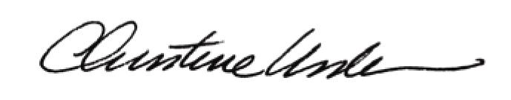
By:

Date of Meeting: August 21, 2017 Title: Historic Officer

